Accessing Pay Stubs through MyCentral
- Select the Employee tab
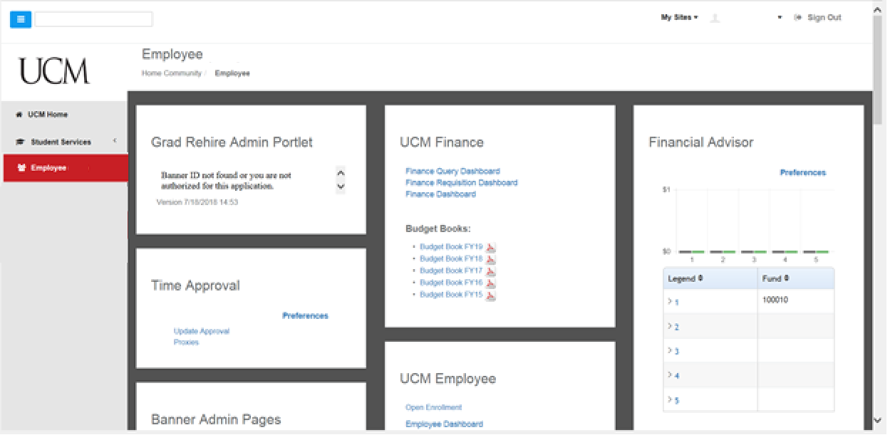
- Select Employee Dashboard in the UCM Employee box

- Pay Information Options will be as displayed below your image:
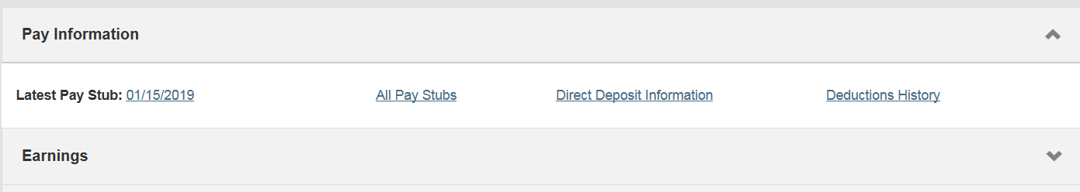
- Clicking Pay Information will bring you to the “All Pay Stubs” Option:
- Click “All Pay Stubs”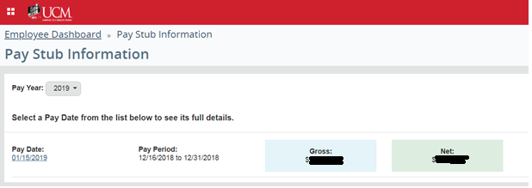

- Choose a Pay Year from the drop-down box to bring up a screen that lists all the available paystubs for the year selected. (For each pay stub you will see the pay stub date, the pay period begin and end dates and the gross and net pay for each pay stub.)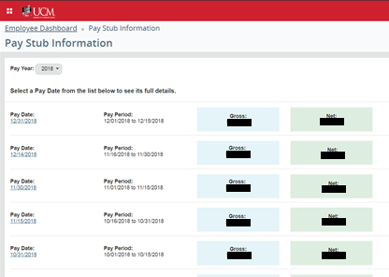

- Then click the Pay Stub Date (far left column) to access the pay stub for the desired pay period
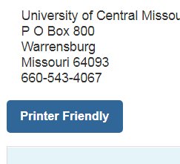
- A printer friendly version of the pay stub can be viewed by clicking the “printer friendly” button at the top of the screen

